TABLE NAME : CUSTOMER_DETAILS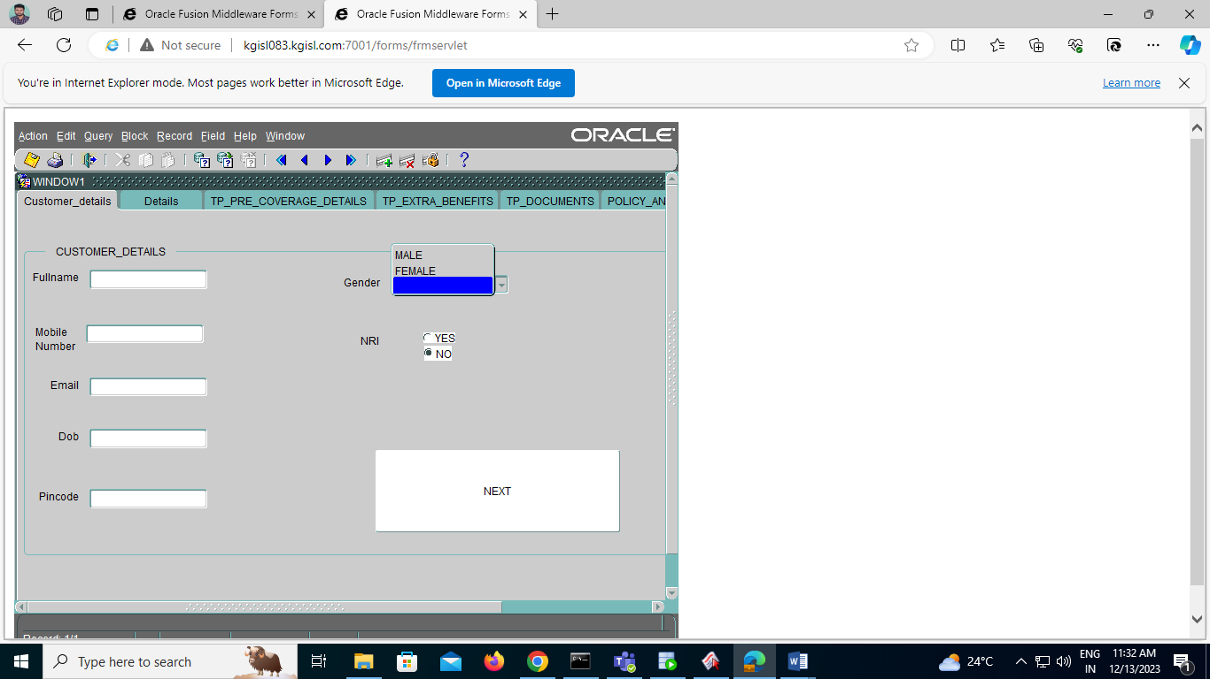

TABLE NAME: DETAILS

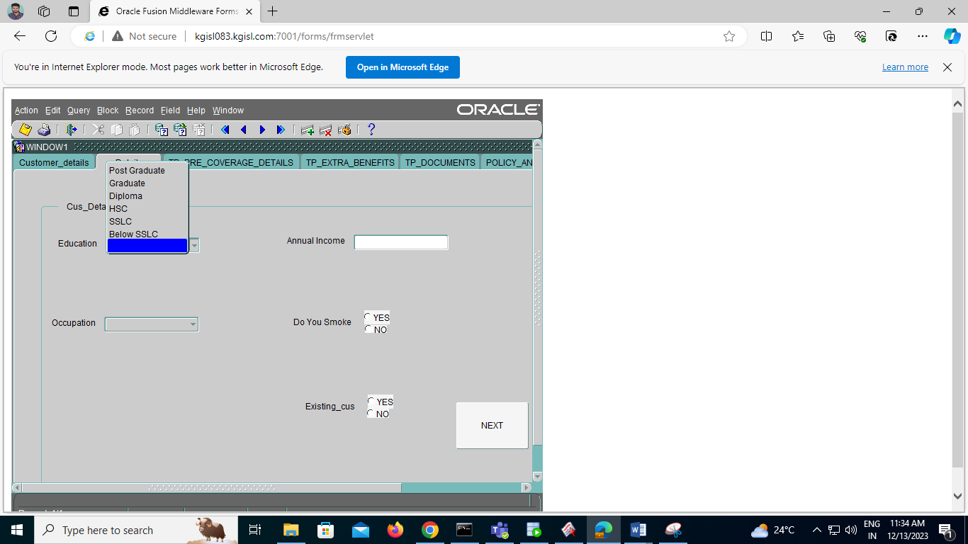

TABLE NAME: DETAILS

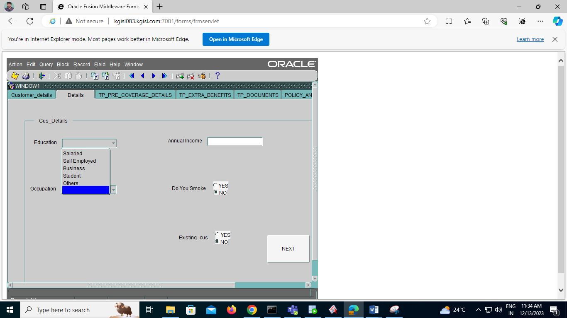

TABLE NAME: TP_PRE_COVERAGE_DETAILS

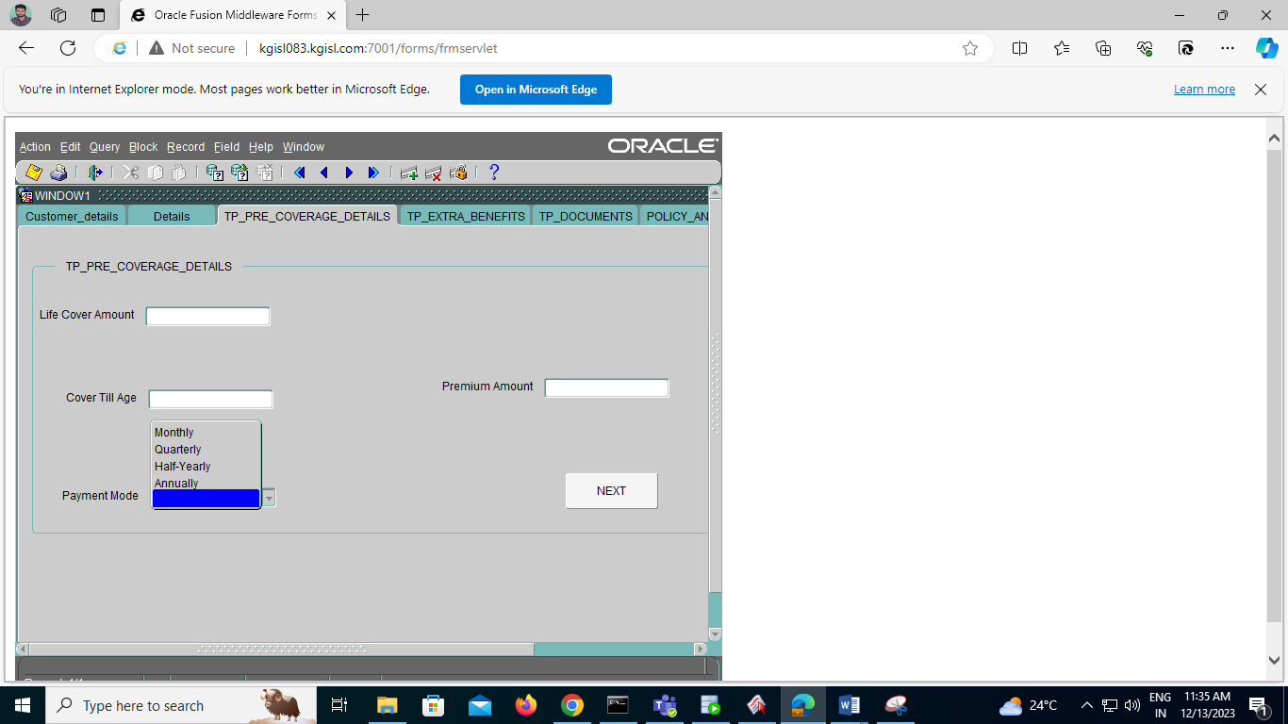

TABLE NAME: TP_EXTRA_BENEFITS

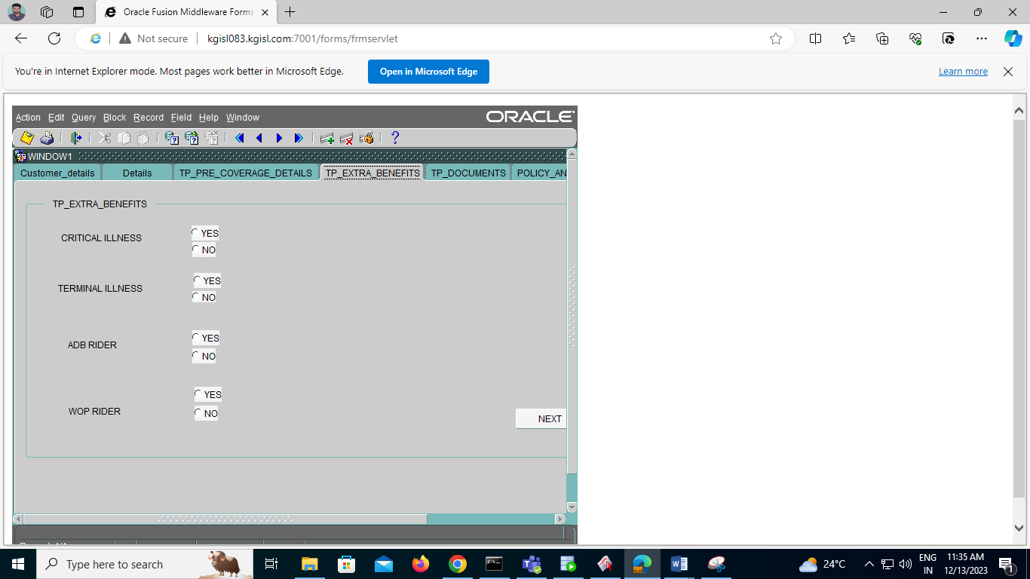

TABLE NAME: TP_DOCUMENTS

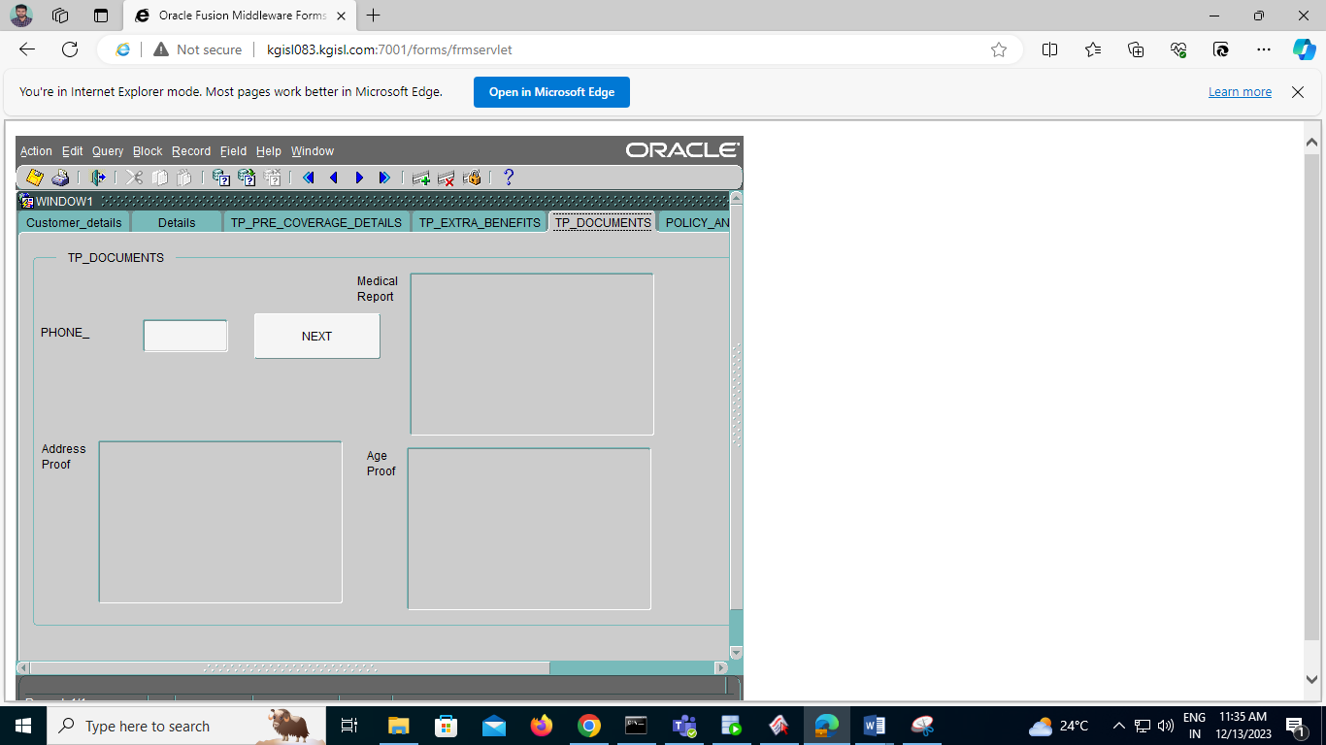

TABLE NAME: POLICY_DETAILS

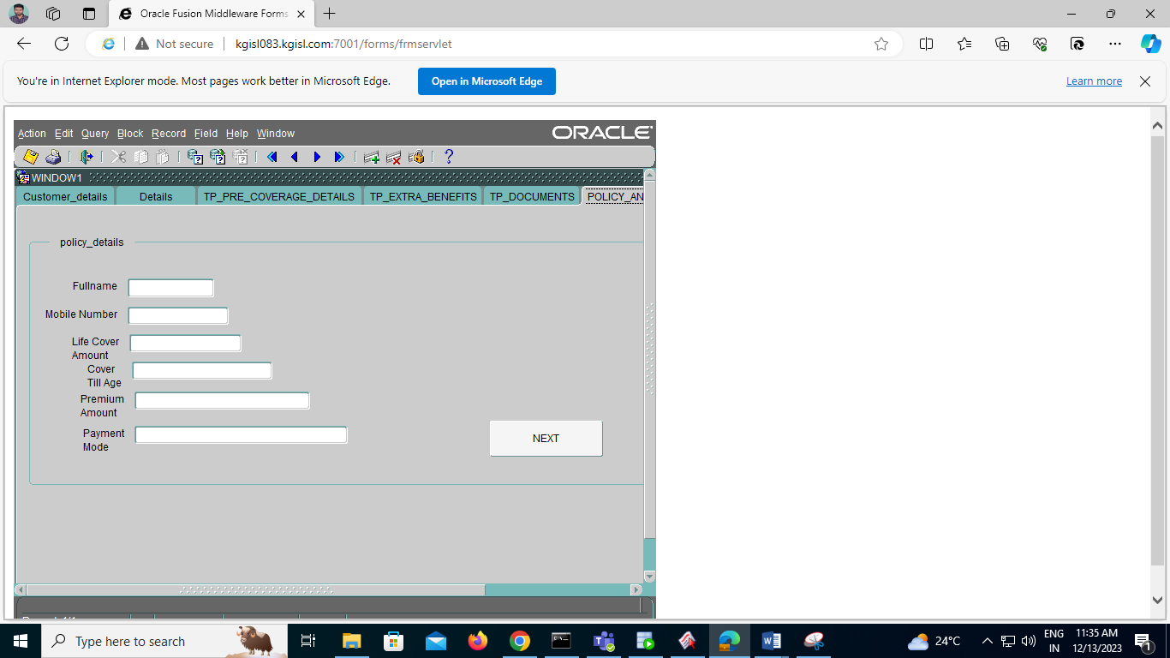

TABLE NAME: ISF_PAYMENT

